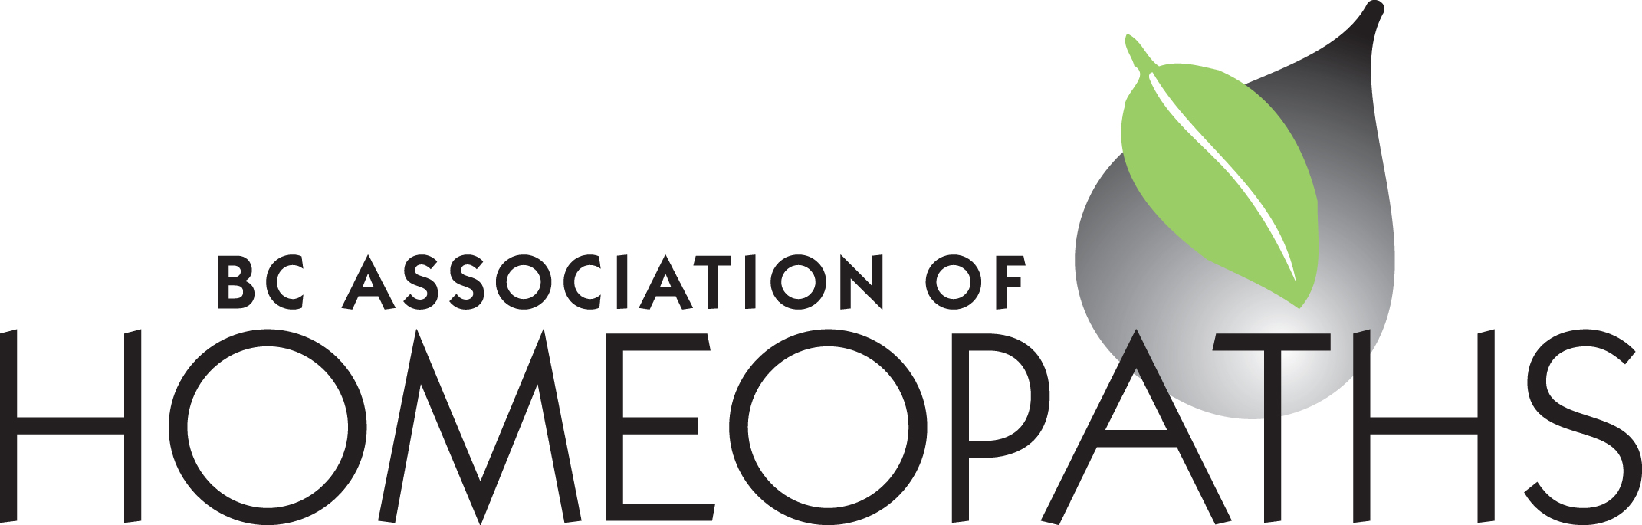

BC Association of Homeopaths Suite 352 – 71 West 2nd Avenue Vancouver, BC V5Y 0J7

www.bchomeopathy.ca

BCAH Board Meeting Wed August 23, 2023

Present: Marie Lamey, Nathalie Allen, Nicole Duelli

Absent: Lynn Mackay, Harkirat Kaur, Heather Schofield

1. Acceptance of meeting agenda – Marie moved to accept the meeting agenda and all were in favour.

2. Acceptance of minutes from last meeting (July 26, 23) – Marie moved to accept the last minutes of the meeting with a few minor edits, and all were in favour.

3. Board updates from Treasurer; Membership; Secretary. Nathalie corrected the cashflow and balance sheet of 2022 and this information will be used moving forward. Our financial year ends this month - August. No other updates.

4. Committee updates: Nathalie sent the final updates with the Report and the link to the survey but I only heard from Lynn and Marie. This is a majority. Nicole will send an email to Harkirat and Heather for potential updates. The Committee will write the text and the link to the google survey. Marie will copy and paste the link and pdf of the Report. We plan to send the report and survey to the BCAH members – pro to sending the Report to non-members, they could see that we are working on something. Please share with your colleagues, we want to hear from and give a voice to all homeopaths in BC. Participate please. The report talks about the profession, but what is their opinion in general. Marie will send out reminders with an October 10 th deadline.

5. CHA &amp; CCFH updates – no updates – see #6.

6. NHP cost recovery proposal. Letters were sent out on behalf of the CHA, the Coalition and the BCAH. The online survey was filled out by most. Marie’s MP was very receptive and said he’d received a lot of letters and is also concerned about it.

7. Case Conference: Marie added the potential for a case conference to the last Mailchimp but there was no response. We could send out another Mailchimp with a video conference plan but if anyone is interested in an in-person conference to please contact us. The AGM is November 4-5 th weekend.

8. BC HPOA discussion of next steps – Marie emailed the legal researcher but has not received a response yet.

9. Item(s) from the list of other business below.

10. Date for next meetings: September 20, 2023 at 7:00pm

Other Business:

11. Complaints Process and reply from the lawyer

12. Member Handbook – finalizing updates &amp;amp; Nicole’s email from Committee

13. Work on a check list of all the steps needed for new Members

14. Working with schools for new members

NOTE: Michelle will attend the next Sept 20th board meeting to discuss website options with

the board

To do list:

Recruit membership coordinator