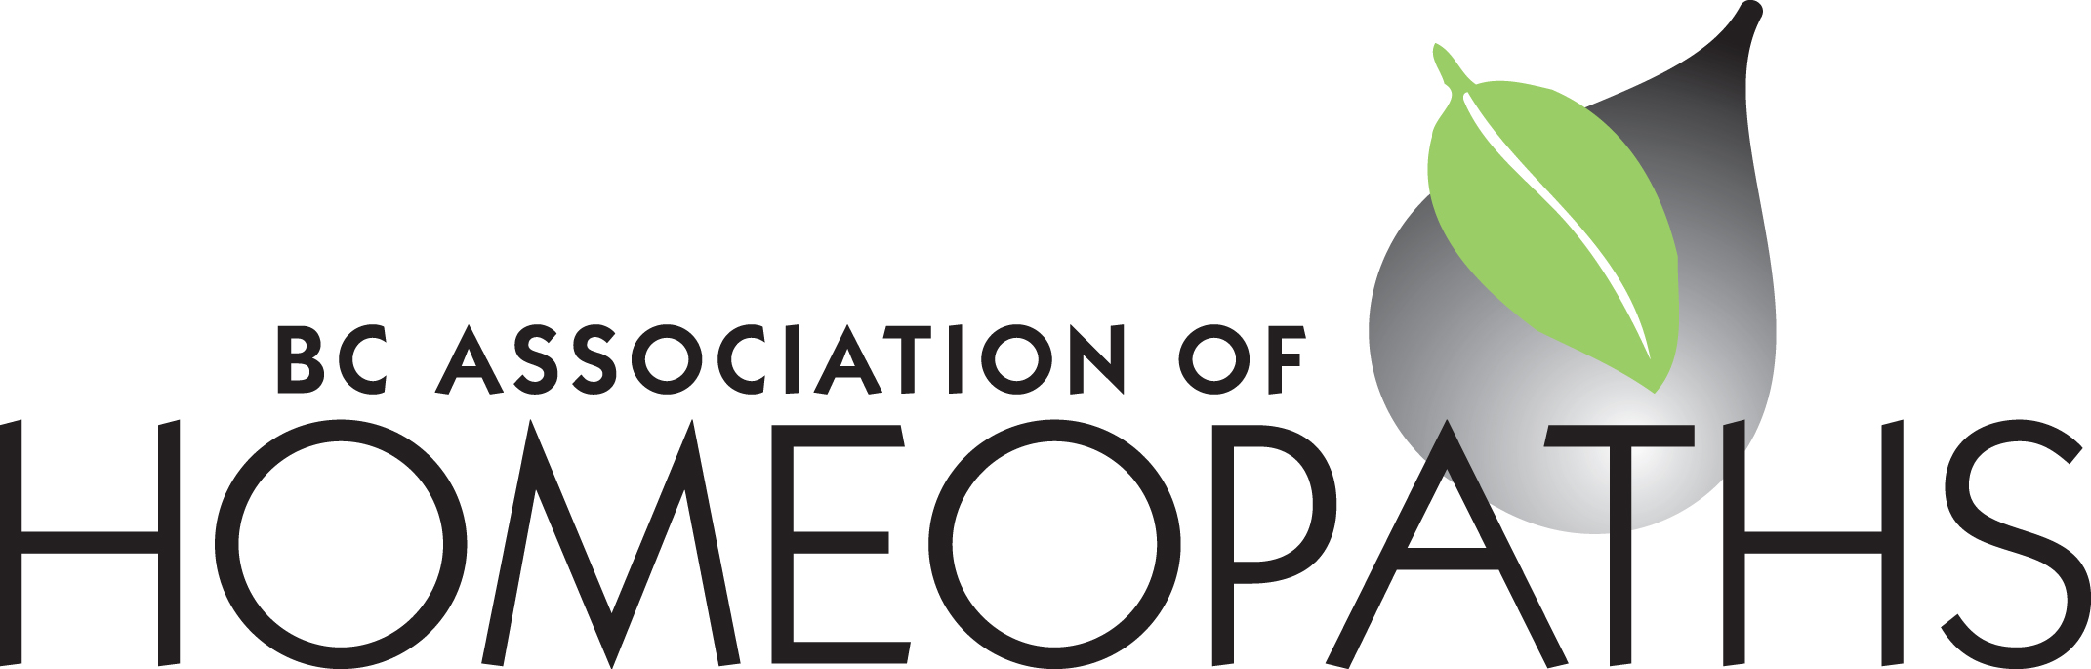

BC Association of Homeopaths Suite 352 – 71 West 2nd Avenue Vancouver, BC V5Y 0J7

www.bchomeopathy.ca

BCAH Board Meeting Minutes Wed July 26, 2023

Present: Nicole, Nathalie, Heather, Lynn, Marie

Absent: Harkirat

1. Acceptance of meeting agenda Moved to accept agenda -all accepted

2. Acceptance of minutes from last meeting (June 28, 23) Accepted last meeting minutes from June 28th 2023 All moved to accept the minutes from June 28th 2023

3. Board updates from Treasurer; Membership; Secretary Minutes are up on website New membership information sent by Nathalie to Anurhada V and website info added by Marie. Nathalie updated official file registry on new membership excel sheet. Cost for a July 29th special meeting -platform upped- one time fee of $340 approx. Max hosting for 1000 people because it’s a national invitation. Invites have gone out and Marie will send out a reminder on mail chimp.

Committee report: Changes to be made by Nathalie before sending out. Action: Lynn to add new member to group i.o.

4. Committee updates &amp; review of document The report was reviewed and completed incorporating feedback. The survey was discussed explaining that this format is simple in order to be accessible and to encourage feedback from many different people not just homeopaths. Action: The report will be sent out by Nathalie with the edits for a final review. Nathalie will also send the committee survey draft for approval by the Board.

Comments to be sent by email to Nathalie by August 10th

5. CHA (CHLIA Expo) &amp; CCFH updates

CHLIA expo - powerpoint presentation have been emailed to the Board.

CCFH updates: Marie created Go Fund Me Page today. It will be shared shortly.

6. Saturday webinar presentation re HC Cost Recovery plan July 29th 10 am.

Marie is still working on powerpoint- Suzanne Sutherland informed Marie that she has connected with CFIB (Canadian Federation of Independent Business) They are a lobby group. This group was instrumental in getting loans out to businesses during COVID- they are frequently active on the news - and include businesses across Canada. Membership is

required along with a submission of a ticket to ask them to ‘do something’. Marie and David from CHPA spoke with the group representative who requested information from Marie. They lobby about the business impact on people’s livelihood.

Marie sent information but has not received any feedback since this information has been sent. The rep wanted to present at the Saturday July 29th meeting to inform members about how they can help us. Marie will gather more information from the rep. before agreeing to this.

Conversation about the possible impact of appointment of a new Health Minister including the possibility for a proper review of the process. Discussion of how some companies are creatively re-defining products to be placed under the cosmetic labels instead.

Nathalie will be co host with Marie and they will do a dry run before the weekend.

Action: Marie will inform Nathalie of the dry run time. Heather will attend if it’s this

Friday.

Marie will email the powerpoint to Nathalie and Heather.

Lynn will attend.

7. BC HPOA discussion of next steps Marie has email address and contact information

Action: Marie will ask the legal researcher Jeremy to present and what the costs would be

next week.

8. Website – inviting Michelle to a board meeting to discuss the options with the board August 23rd is the date for the next meeting. This may change if enough Board members cannot attend. Decision to invite Michelle for Sept 20th as more people will attend.

9. Item(s) from the list of other business below

Deferred

10. Date for next meetings

**August 23rd and Sept. 20th**

Other Business:

11. Case Conference

12. Complaints Process &amp; reply from the lawyer

13. Member Handbook – finalizing updates &amp; Nicole’s email from Committee

14. Work on a check list of all the steps needed for new Members

15. Working with schools for new members

To do list:

Recruit membership coordinator