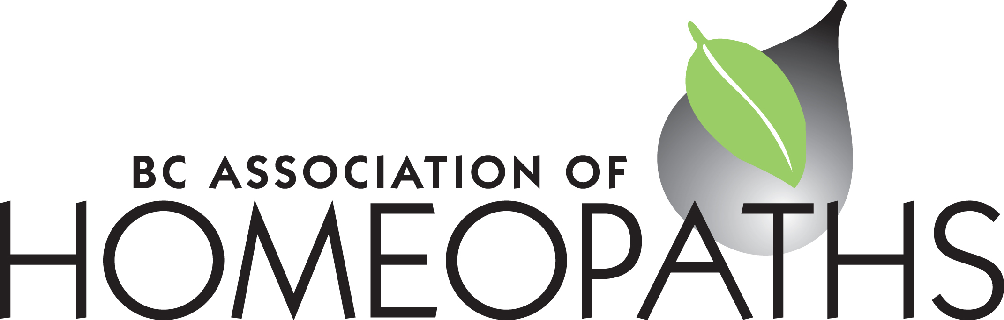

BC Association of Homeopaths Suite 352 – 71 West 2nd Avenue Vancouver, BC V5Y 0J7

www.bchomeopathy.ca

BCAH Board Meeting Wednesday March 20th, 2024 at 7 pm.

Present: Marie Lamey, Lynn Mackay, Nathalie Allen, Nicole Duelli

Absent: Harkirat Kaur

1. Acceptance of the meeting agenda. There was a motion to accept the agenda and all were

in favor.

2. Acceptance of the minutes of the last meeting (February 28, 2024) was accepted

unanimously with minor edits.

3. Board updates from the Treasurer, Membership secretary, Secretary: membership renewals

and CEU’s were discussed. Nathalie was having some issues with logging into Wordpress

as a member as she is also a director, but it worked by logging in to a different computer.

Some payments were done without the discount code. There was a discussion about

refunding them but due to the complexity, it was decided that refunds would be issued on an

as requested basis. The issue is that it appears that doing a partial refund in PayPal causes

MemberPress to unsubscribe them entirely. Furthermore, there are some other details that

the new system does not accommodate for. For example members can’t change their

registration from the year before: for instance if you were a student last year, then you’ll

automatically be sent the renewal as a student. Marie will check with Michelle about those

details like the bypassing of the forms and completing payments without uploading CEUs

which some members have also managed to do - not everyone is following the checklist as

outlined in the membership renewal email. As a result, there is a learning curve with the new

system and Marie still has to check three things - the MemberPress form, the uploaded

CEUs and PayPal payments to make sure all have been done correctly. While this is

onerous, it is easier than it was before. Payments without forms and forms without payments

make extra work. Next year let’s make sure the glitches are ironed out, the coupon codes

are included and the steps for renewal are clear. People also need to be reminded about the

CEUs, that they don’t roll over and that they know that even if they’ve been practicing for

over 30 years, they still have to do CEUs.

4. CHA & CCFH updates: there is a Health Canada meeting March 27th. The meeting with

Health Canada is at 6:30 am Vancouver time with the Coalition and Marie will attend to give

an update at the next meeting. Furthermore, the Canada border services agency. (CBSA)

Victor got a letter saying that they were confiscating his Helios package when he ordered 15

remedies - 7ml each - as dangerous goods. Is 100ml the threshold? Canada Post has

documents on non-mailable matter. Alcohol is a flammable material. Marie spoke with

someone with Canada Post but wasn’t able to get clear information. Maybe a customs

broker would have more information on the potential border issue.

5. Watch party for Homeopathy - the Film: the venue is booked as the YWCA on Beatty St. -

we have enough space for 80 people. A few of people have already confirmed. We have the

room from 5-9 pm. People can arrive at 5 pm and mingle and the movie can start at 6 pm.

update on RSVP’s and discussion of food and beverages. The date is Saturday April 20th.

Pizza, sushi and wraps were discussed as possibilities. Although it’s nice to have food,

pizza could get cold and sushi could get warm. Bubbly water and sodas are a possibility -

Nicole can bring but will need some help with delivery.

6. Discussion on starting a WhatsApp group for members, and/or a monthly meeting for

members - Lynn. The groups.io isn’t functioning that well. WhatsApp could be more

professional. Exchanging information about webinars and less formal. Each group could

have its place. How do we create community? Possibly there could be a community of

people who initiate conversations on WhatsApp - we could create topics, what have people

done for their CEUs. Saroj from the Ontario Association is very active on Whatsapp. Let’s

ask Harkirat if she’s interested in hosting or starting a group. It can be a link that is sent over

email. And Nicole mentioned that possibly we could discuss the topic “creating a community”

as a wrap up for the Committee. Could be good to start up a conversation. Nicole to contact

Harkirat to ask about the possibility of starting a WhatsApp group.

7. Case conference - potentially for June 2024? We could use the YWCA again for the movie.

Didn’t like the SFU experience last time as there was a singing group close by. The fall, in

September may be a better month. Potentially the second week of September 7 or 8th - or

combine it with the AGM.

8. Mailchimp Notice for April to include 2 new members, reminder of the Watch Party. That will

include the updates on Health Canada NHP cost recovery program. Call for presenters for

the case conference in the Fall.

9. At the last meeting we discussed adding manufacturer’s resources to the website but the

website for the homeopathy manufacturer in India had clothes and other items for sale so

we will need a different addition. Nicole will speak with Harkirat to see if she has any

recommendations.

10. Next meetings**: April 17, 2024 at 7 pm, May 22, 2024**